* **Lab Task 4:**

Write a SQL query to find the employee's name, department name, full name (first and last name) of the manager, and their city.

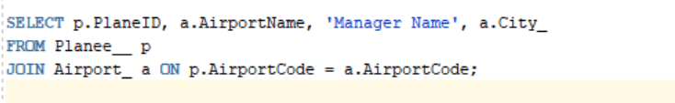

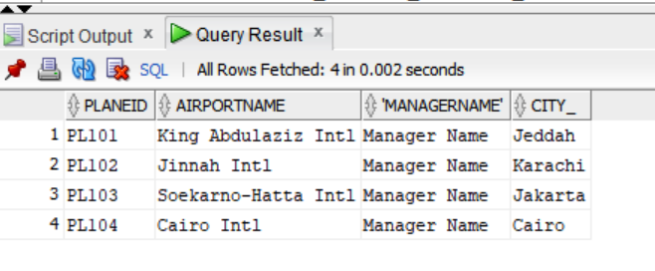

OUTPUT: